CSA1519-CLOUD COMPUTING FOR BIG DATA ANALYTICS
LAB EXPERIMENTS

NAME: P SUDHARSHAN REDDY REG.NO: 192372204

EXPNO 8: CREATE A VIRTUAL MACHINE WITH 1 CPU, 2GB RAM AND 15GB STORAGE DISK USING A TYPE 2 VIRTUALIZATION SOFTWARE.
AIM:
To create a virtual machine with 1 cpu, 2gb ram and 15gb storage disk using a type
2 virtualization software.
PROCEDURE:
STEP 1:Dowload VMware workstation and installed as type 2 hypervisor.
STEP2:Dowload ubuntu or tiny OS as iso image file.
STEP 3: In VMware workstation->create new VM.
STEP 4: Do the basic configuration settings.
STEP 5: Created tiny OS virtual machine.
STEP 6: Launch the VM.IMPLEMENTATION:
STEP 1:DOWLOAD VMWARE WORKSTATION AND INSTALLED AS TYPE 2 HYPERVISOR
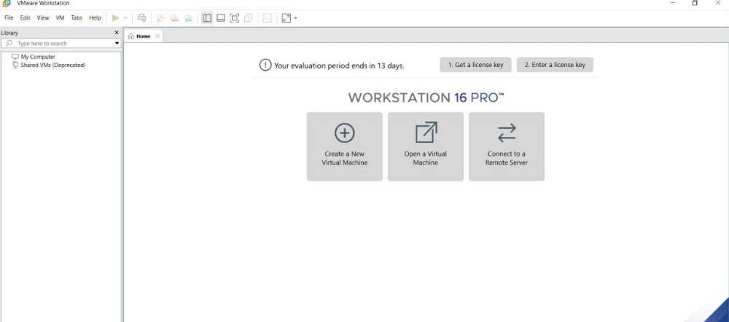
STEP2: DOWLOAD UBUNTU OR TINY OS AS ISO IMAGE FILE
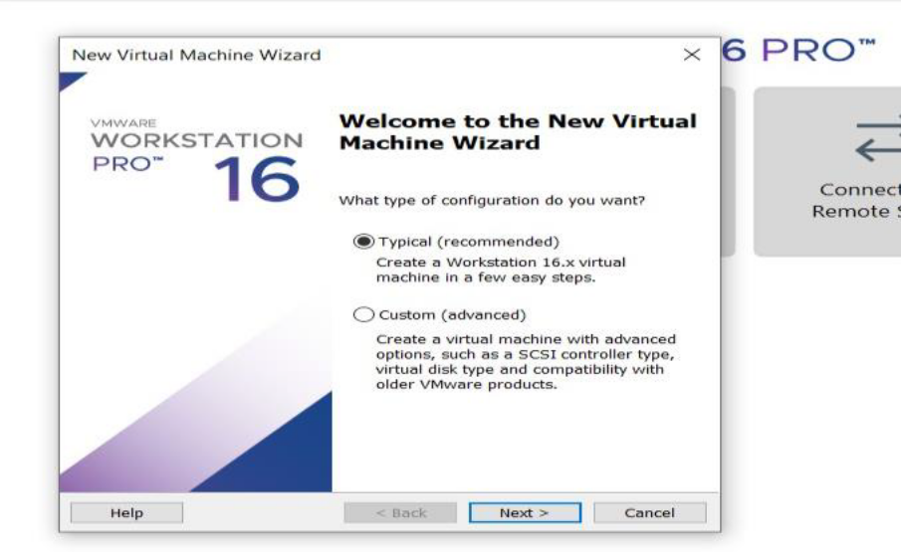
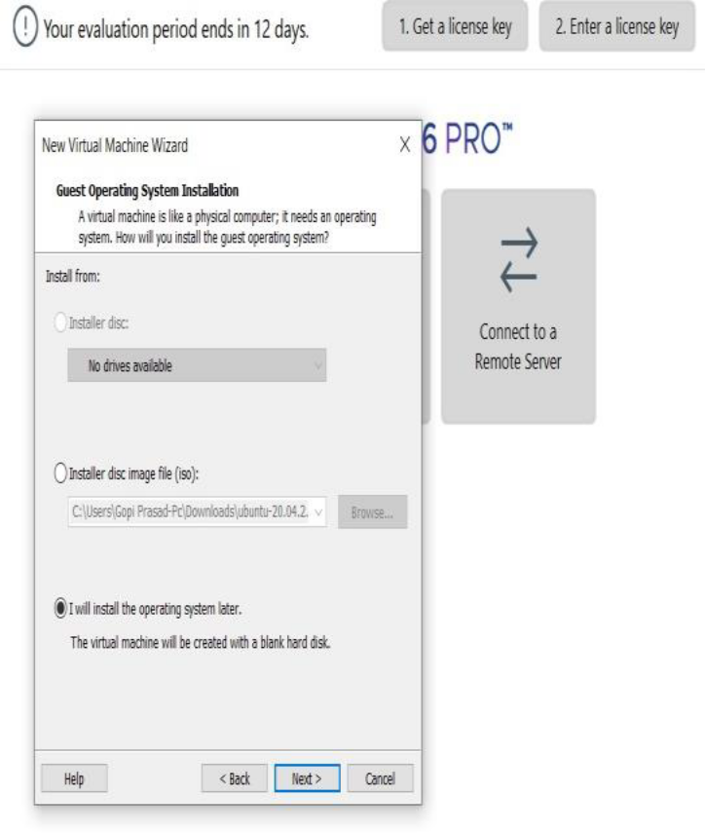
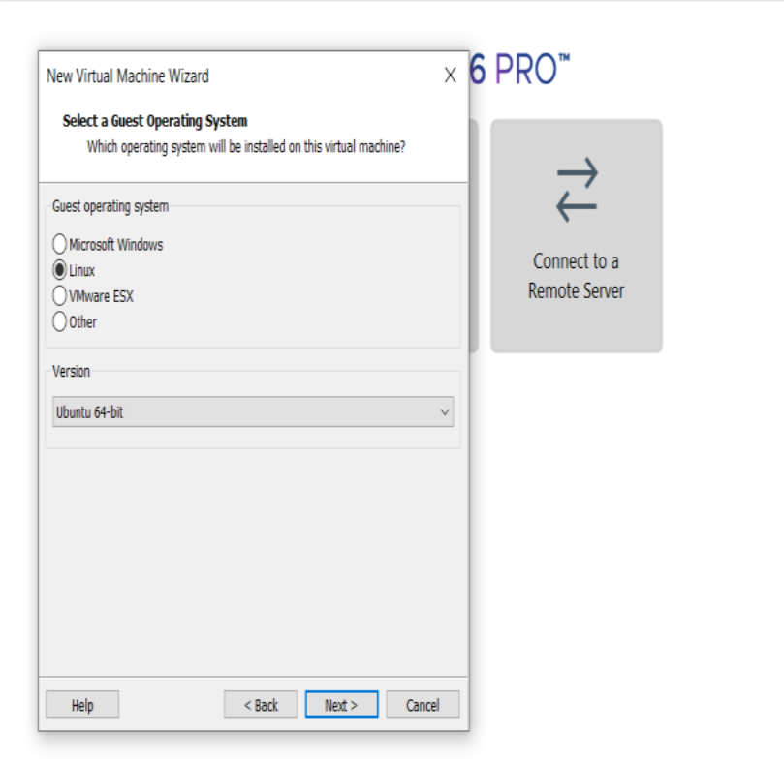
STEP 6: LAUNCH THE VM
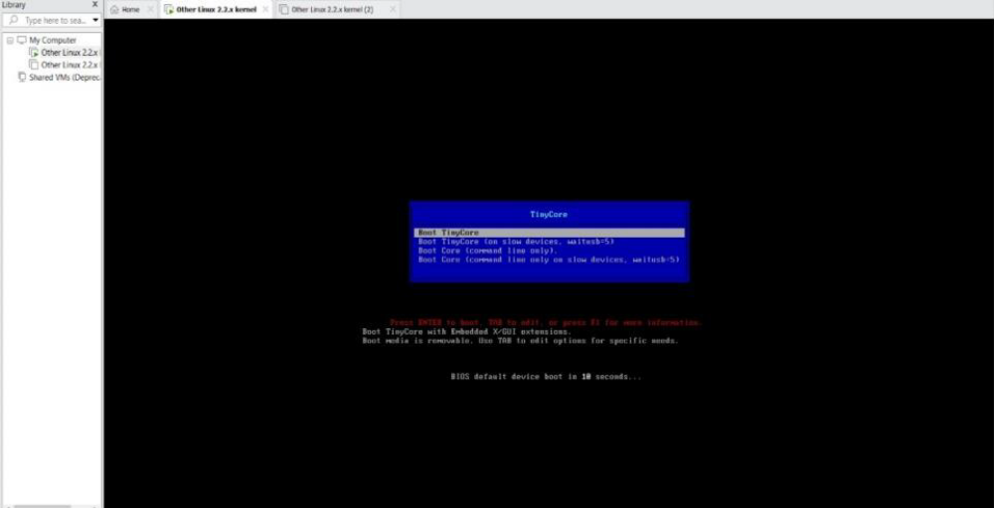
RESULTS

